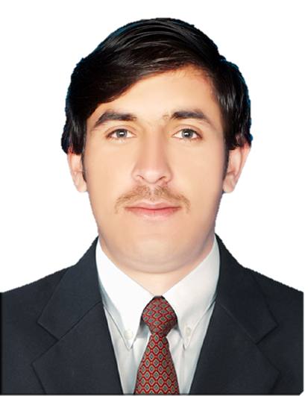
CURRICULUM VITAE
INAM ULLAH
Requesting Job, Petroleum Engineer
CAREER VISION:
I believe in dignity, honesty, sincerity, perfection, team work and commitment, I try my best to achieve standard & quality work results, I always strive for improvement. To contribute towards the development & growth of dynamic organization where I can utilize my knowledge & skill effectively & efficiently
ADDRESS & CONTACT & QUALIFICATION:
ADDRESS: Mohalla BarPallow, Village Kharerai, Tehsil& P.O Matta, District Swat, Khyber Pakhtunkhwa, Pakistan.
E mail: inamk334@gmail.com
CONTACTS: (0092) 341-2009598
(00971) 55-9615015
QUALIFICATION
- Metric 2010
- FSC 2012
- BS (Petroleum & Gas Engineering) 2017
PERSONAL DATA:
- Passport, KP2749351
- Issue Date, 25 Sep 2017
- Expiry Date, 24Sep 2022
- Date of Birth, 13/05/1993
- Place of Birth SWAT, Pakistan
- NIC No, 15601-1375935-1
- Civil status, Single
- Nationality, Pakistani
- Father Name, Mohammad Rafiq

COMMUNICATION SKILLS:
Urdu, English, Pashto

COMPUTER SKILLS:
MS Office, Word, Power Point, Excel, Windows, Hardware and Software.
PERSONAL SKILLS:

- Served as Class Representative for 1 consecutive years.
- Member of SPE International (Membership #4183413)
- Work Voluntarily with Student Affair at BUITEMS.
- Member of AAPG (American Association of Petroleum Geologist)
- Serve as Volunteer in United Nation (UN)
- Excellent written and verbal communication skills.
- Highly organized and efficient.
- Ability to work independently and as a team.
- Having ability of working in highly Worm and cold weather.
- Proven leadership skills and ability to motivate.
CERTIFICATION:
- Served as Membership Committee of Society of Petroleum Engineering SPE Student Chapter BUITEMS Quetta
- Drilling Fluid Technology [From HEC]
- Drilling Rig Course [From CPC]
- Office Automation [From NIDA]
- Percentage Certificate [From BUITEMS]
- Provisional Certificate [From BUITEMS]
- Medium of Instruction certificate [From BUITEMS]
- Good Character Certificate [From BUITEMS]
- Best Player (Cricket) Certificate [HIRA College]
PROJECTS:
- Finial Year Project on “Effect of Induced & Natural Fracture on Production of Shale Gas.”
- Term Research on “New Techniques Enhance Oil Recovery.”
EXPERIENCE:
Working with MARI GAS DRILLING Company in-Pakistan as a ROUSTABOUT from
05/Apr/2016 to 21/Sep/2017.

ONSHORE RIG COURSES (Pakistan)
- FIRST AID / CPR, Training Course, (SGS Pakistan)

- FIRE FIGHTING, Training Course, (SGS Pakistan)

- H2S, Training Course, (SGS Pakistan)

- CONFINED SPACE ENTRY, Training Course, (SGS Pakistan)

- CRANE & FORKLIFT SIGNALS, Training Course, (SGS Pakistan)

- WORK AT HEIGHT, Training Course, (SGS Pakistan)

- RIGGING & SLINGING, Training Course, (SGS Pakistan)

- PERMIT TO WORK, Training Course, (SGS Pakistan)

RESPONSIBILITIES AS ROUSTABOUT:
Cleaning, washing, housekeeping, Chipping, buffing, Painting, Mixing, Scraping, Hammering
Drifting, loading unloading,
- Help to drilling crew & maintenance crew & supported Crew time to time,
- All work’s follow the team work,
- Obey the senior order always,
- Use proper P.P.E always,
- Must follow the PTW & JSA procedure always,
- Follow the all safety rules in during operation,
- Good be heavier & good communication to other guys,
- Assisting in dismantling rig equipment’s during rig move and reassembling on the new location.
- Assisting derrick man for work on shale shakers e.g. changing screens etc.

